Supplementary Information for
Integrated self-referencing single shot digital holographic microscope and optical tweezer
Subhash Utadiya, Sachin Joshi, Nimit Patel, Chetna Patel, Mugdha Joglekar, Vani Cahhniwal, Timothy O’Connor, Bahram Javidi, Arun Anand
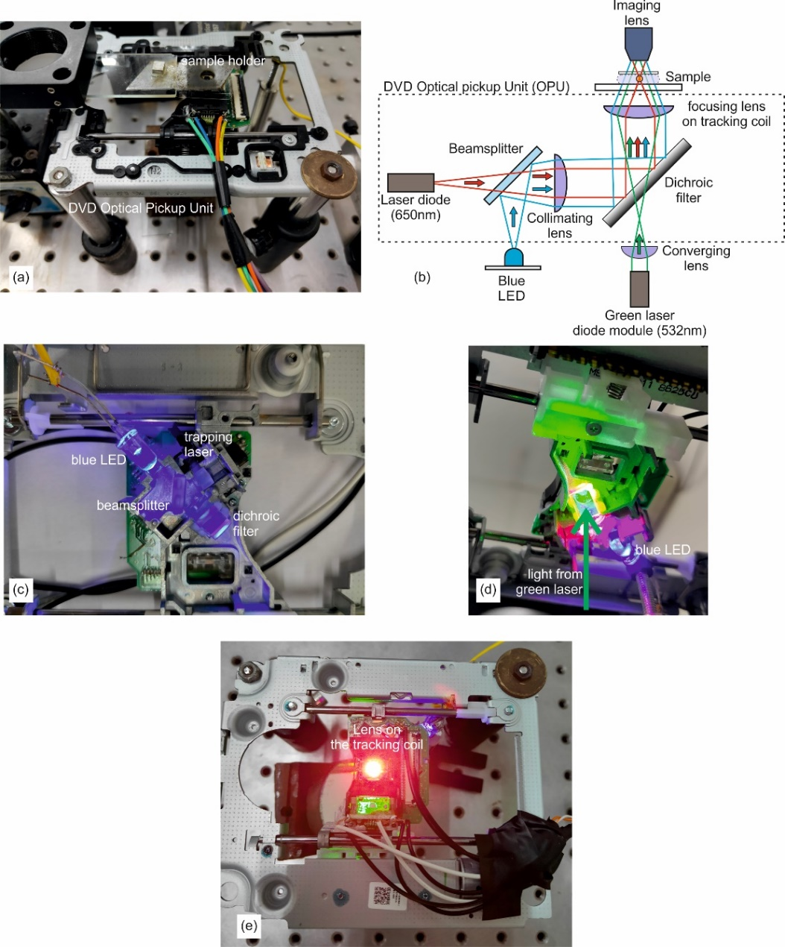
Supplementary Figures:

Fig. S1: (a) Optical pickup unit used for trapping of microparticles and location of the sample holder. The lens used to focus the trapping laser beam is just below the sample holder. (b) Schematic of the DVD Optical Pickup Unit. The beam from the trapping beam (laser working at 650 nm) is focused on to the sample using a collimating lens and lens mounted on the tracking coil. Light from the blue LED (used for bright field imaging) is coupled to the focusing and then to the imaging lens through a beam splitter and a dichroic filter. Output from the green laser diode module is coupled to the focusing lens and the imaging lens through the dichroic filter. (c) and (d) View of the bottom of the DVD-OPU showing how different beams (trapping, bright filed imaging and holographic) reach the sample and the imaging lens. (e) Output from the lens mounted on the tracking coil (lens used for focusing the trapping beam).
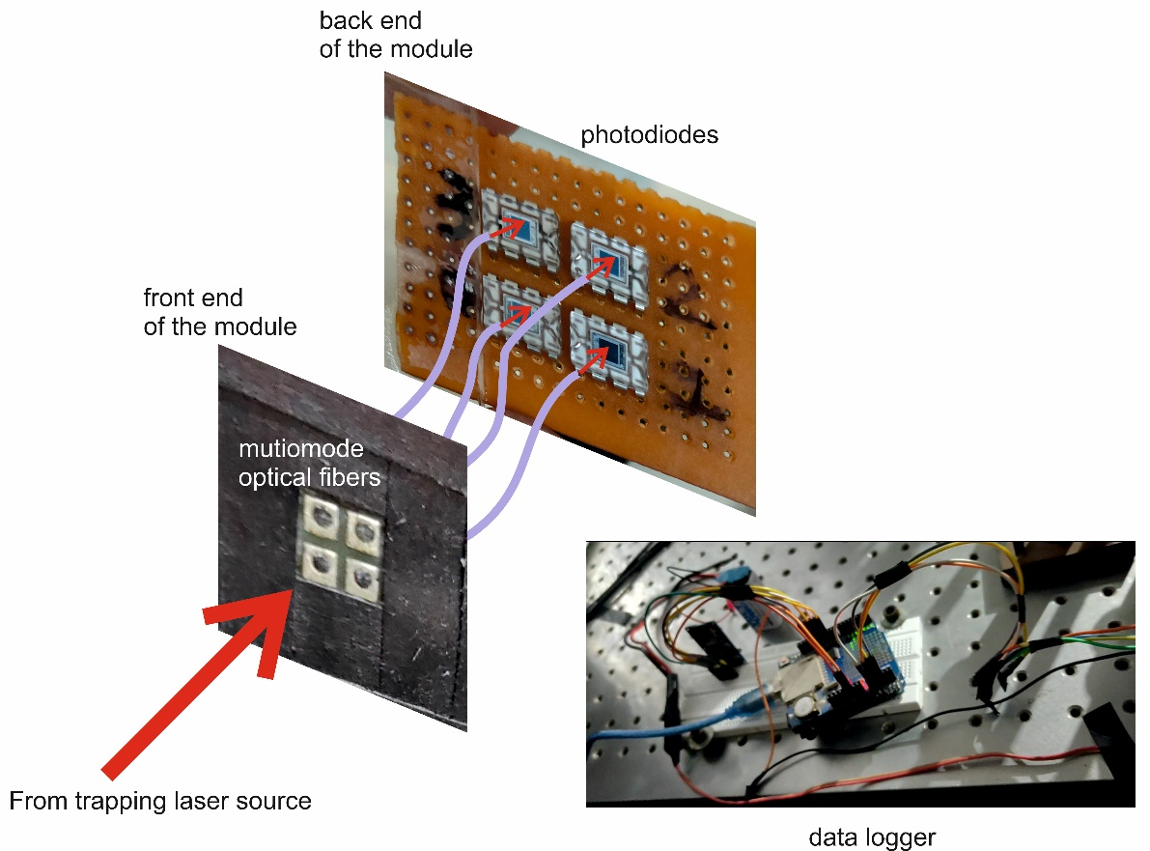
Fig. S2: QPD system developed using multimode optical fibers and photodiodes. Four multimode optical fibres to couple the trapping beam on to the photodiodes using a lens of focal length 25 mm, which is placed after the red filter. In the described devise we used four photodiodes (OPT101) in a 2x2 format. However, using these photodiodes led to significant separation (due to the large area of the diodes and circuitry involved) between the individual diodes compared to standard QPDs available, making position determination difficult. To overcome this hurdle, closely spaced multimode optical fibres in 2x2 format were used to collect the laser light for position detection. The light collected by the optical fibres was then delivered to the photodiodes at the module's backend. The front end of the fibres was positioned such that the beam spot covered all four fibers. This geometry is equivalent to four closely spaced photodiodes.
Supplementary Videos:
Video V1: Working of the optical trap integrated with Self-Referencing Digital Holographic Microscope.
Video V2: Micromanipulation of 15 μm diameter polystyrene microsphere. Video was recorded at 15 fps for 30 s. Scalebar represents 10 μm
Video V3: Micromanipulation of 5μm diameter polystyrene microsphere. Video was recorded at 15 fps for 30 s. Scalebar represents 10 μm
VideoV4: Time Series of holograms of trapped microsphere (15 μm diameter). Video was recorded at 30 fps for 10 s. Scalebar represents 10 μm
VideoV5: Time Series holograms of trapped red blood cell. Video was recorded at 35 fps for 16 s. Scalebar represents 5 μm
VideoV6: Time variation of optical thickness profile of red blood cell obtained from Video V5. Scalebar represents 5 μm
VideoV7: Optical Thickness fluctuation of red blood Cells. Fluctuation profile was computed from thickness variation in each second. Scalebar represents 5 μm

