Supplementary Information

‘Plug-and-play’ plasmonic metafibers for ultrafast fibre lasers
1. Nanofabrication of the metafiber using EBL
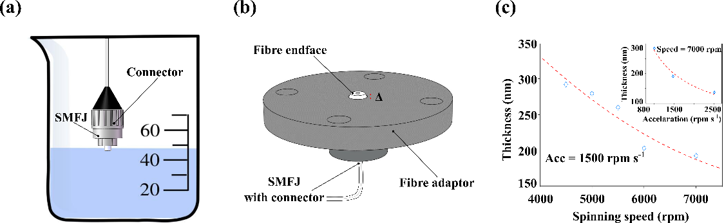
Fig. S1. The schematic process flow of nanofabrication on the fibre tips of SMJPs using EBL. (a) Pre-cleaning a SMFJ tip. (b) Home-built fibre adapter. (c) The thickness of electron-sensitive resist as functions of spin-coating speed and the acceleration (inset). The blue diamonds and the dashed red curves are the experimental and fitted data, respectively.
To fabricate the well-patterned metasurfaces on the endface of a commercial single-mode fibre jumper (SMFJ) by using electron-beam lithography (EBL), standard procedures including cleaning, spin-coating, electron-beam exposure, development, physical vapor deposition and lift-off are performed. A SMFJ is cut into two identical parts, each of which maintains a standard connector in one end. The fibre tips with the connector of SMFJs are dipped into chemical solvents of a beaker (Fig. S1(a)), and then sequentially cleaned by acetone, isopropanol and deionized water in an ultrasonic sink for 10 min for each step. The fibre tips are dried by nitrogen flows and then mounted to a coaxial fibre adaptor (Fig. S1(b)), while the other end without the connector passes through a hole drilled at the bottom of the rotating/translating chunk and twines around the body, as illustrated in Fig. 1(b1-b3). The top surface of the fibre adaptor is designed slightly lower than the SMFJ endface, so that the spreading resist isn’t bounced back once it touches the tip-adaptor boundary during the spin-coating. The fibre adaptor can be connected with a home-made rotating chunk via four screws, as shown in Fig. 1(b1) in the main text. The bottom part of the rotating chunk is designed to adapt a commercial spin-coater (SUSS MicroTec). 30 uL of electron-sensitive resist (PMMA 950K, Allresist) is dropped on the fibre tip. In accordance with our empirical database (Fig. S1(c)), the following parameters for spin-coating are prudently used to obtain a 200 ± 5 nm thickness of electron resist: speed-7000 rpm and acceleration-1500 rpm s⁻¹. The rotating chunk is then flipped top down and placed on a hot plate for soft baking (175 ℃ for 3 min), as shown in Fig. 1(b2) in the main text. The spacing between the fibre endface and the top surface of the hot plate is guaranteed by the screws’ heads: 2.5 mm. The fibre tip is then spin-coated with a thin layer of conductive polymer (~ 40 nm, AR-PC 5090.02, Allresist) to weaken the charge accumulations during the electron-beam observations or exposures. The fibre adaptor is removed from the rotating chunk to a home-built translating chunk, which is adapted to the scanning stage of a commercial SEM (Zeiss Crossbeam 550), as shown in Fig. 1(b3) in the main text. After the patterning, the fibre is unloaded from the fibre adaptor and the conductive polymer is first removed by dipping the fibre tips into deionized water. The optical fibre is then sequentially dipped into the developer (Allresist, 1 min) and stopper (Allresisit, 1min) for the development. The well-patterned SMFJ is then transferred to a home-built evaporation adaptor for depositing the target materials (3 nm Cr and 50 nm Au), as illustrated in Fig. 1(b4) in the main text. After remaining the SMFJ into the acetone for more than 24 h, we finally obtain the plasmonic metasurfaces (Au nanorods array) on the SMFJ end facet following a standard lift-off process.
2. Nanofabrication of the metafiber using FIB
The fibre tips of SMFJs are cleaned and dried in accordance with the procedures described above. They are then mounted on a home-built evaporation adaptor, as illustrated in Fig. 1(b4) in the main text. The evaporation adaptor is then adapted to the sample holder of a commercial evaporator (ULVAC ei-5z) for depositing the target materials (3 nm Cr and 60 nm Au). The coated SMFJs are then removed from the evaporation adaptor to the home-built fibre adaptors. A home-built translating chunk connecting the fibre adaptor is adapted to the electrically driving stage of a commercial FIB apparatus (Carl Zeiss, ORION NanoFab, USA) for the milling, as illustrated in Fig. 1(c1) in the main text. There are two kinds of ionized beams in the FIB chamber: He⁺ and Ga⁺, in which He⁺ beam is used for the imaging and the Ga⁺ beam is for the milling. There is an angle of 54° between the two beam columns. During the milling, the translating chunk is tilted an angle of 54° in horizontal direction for a normal milling of the Ga⁺ beam, as illustrated in Fig. 1(c1) in the main text.
We note that there is an air gap of ~200 nm between the two facets of fibre cores to be connected. The thicknesses of the metasurfaces fabricated on the fibre cores by using our EBL and FIB technologies were no more than 60 nm. Therefore, there is no physical contact between the metasurfaces and the fibre core on the other side, avoiding possible contaminations or damages during the plug-in and plug-out procedures. Figs. S2 show the SEM images of the metasurfaces fabricated on the endface of a single-mode fibre jumper before and after the lifetime test (50 times of plug-in and plug-out). As can be seen, no observable contaminations could be found from the metasurface region.
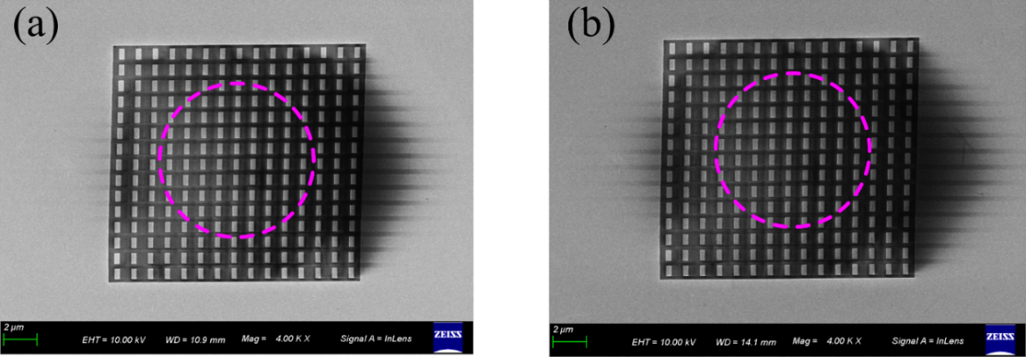
Fig. S2. SEM images of the metasurfaces fabricated on the endface of single-mode fibre jumper before (a) and after (b) 50 times of plug-in and plug-out operations. The dashed pink circles indicate the core boundaries.

3. Linear optical response calculations
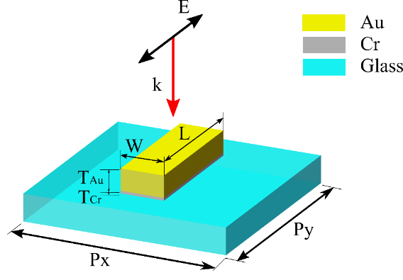
Fig. S3. Optical model of a metasurface unit cell excited with a linearly polarized light. P_{x} and P_{y} denote the transverse and longitudinal periods of the nanorod fabricated on the fibre tip. T_{Au} and T_{Cr} represent the thickness of gold and chromium, respectively. W and L denote respectively the width and length of the nanorod. k and E represent the propagating direction of the plane wave and the polarization, respectively.
In order to calculate the linear optical responses (transmission, reflection, absorption, extinction and the fundamental electromagnetic field distributions), we use the finite-difference time-domain (FDTD) method to model the plasmonic metasurfaces. In such model, as shown in Fig. S3, the Au nanorod and Cr adhesion layer are located on a glass substrate. The refraction index of Au, Cr and glass are obtained from the material library ¹. The nanorod is excited by a linearly polarized plane wave coming from the air side (n_{air} = 1) of the interface. The k vector of the incident light is normal to the substrate plane and the polarization is parallel to the long axis of nanorod. The periodic conditions in both x and y directions are taken into account (Fig. 2(a) and Fig. 5(a) in the main text). The fundamental electric fields in each excitation wavelength (insets of Fig. 2(b) and Fig. 5(b) in the main text) are obtained simultaneously in the calculation process for each dimension of nanorod array.
4. Optical setups for measuring the extinction spectra
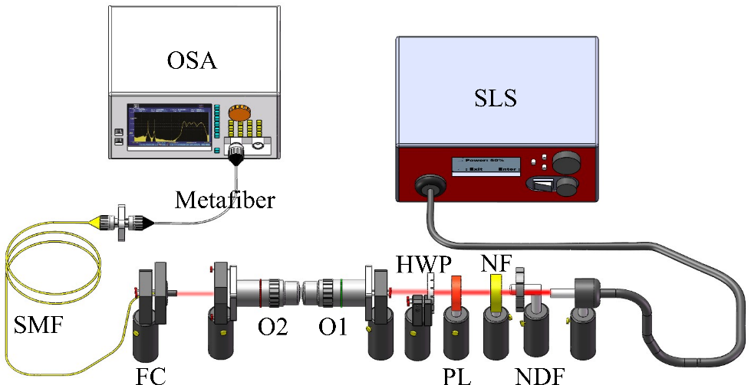
Fig. S4. The optical setups for measuring the polarimetric extinction spectra of a metafiber. SLS is supercontinuum light source, NDF is neutral density filter, NF is notch filter, PL is polarizer, HWP is half wavelength plate, O1, 2 are objective lens, FC is fibre-optic collimator, SMF is single-mode fibre and OSA is optical spectrum analyzer.
As shown in Fig. S4, a supercontinuum light source (SLS, NKT photonics) emitting in the 1–1.8 µm spectral range is firstly filtered via a neutral density filter (NDF) and a notch filter (NF, central wavelength: 1064 nm, band width: 44 nm) to prevent the metafiber from potential thermal damages induced by the pumping laser (1064 nm). A polarizer (PL) and a half-waveplate (HWP) control the polarization axis of the incident light, and two confocal objective lens (O1:2.5/0.08; O2: 20/0.4) changes the beam diameter to fit the fibre-optic collimator (FC) entrance. Before coupling the incident light to the testing fibres, it is necessary to introduce an intermediate single-mode fibre (SMF) to increase the mobility of the optical spectrum analyzer (OSA) and minimize the potential misalignments of the optical path in the free space during exchanging the testing fibres. The transmitted optical signals are sent to the OSA for spectrum analysis.
5. Optical setups for measuring nonlinear optical transmissions
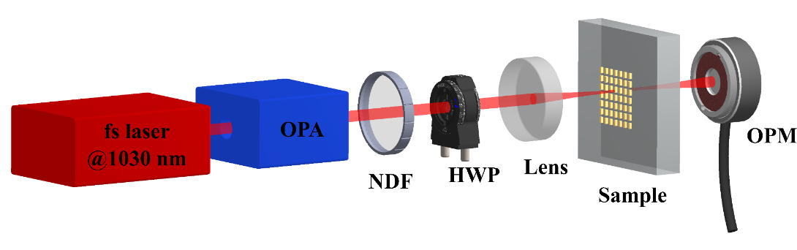
Fig. S5. Optical setups for measuring the nonlinear transmission of a nanorod metasurface. OPA is the optical parametric amplifier, NDF is neutral density filter, HWP is half-wavelength plate and OPM is optical power meter.
Femtosecond laser pulses (pulse duration 130 fs) with a central wavelength of 1030 nm is firstly converted to other wavelengths via an optical parametric amplifier (OPA, Twin Starzz, Fastlite). A neutral density filter (NDF) is used to tune the single pulse energy and thus control the averaged power of incident light. The polarization is linear and can be further tuned by using a half-wavelength plate (HWP, 1100 nm-2000 nm, FBR-AH3c, Thorlabs). The polarization angle 0° on the sample is firstly judged by aligning the polarization with a marker which is parallel to the nanorod long axis, and is fine-tuned by observing the minimum transmission levels after rotating the HWP 360°. A lens (75 mm focal length) is used to focus the beam on the patterns of metasurfaces. The transmitted light is collected by an optical power meter (OPM, 700 nm - 1800 nm, S122C; 1200 nm - 2500 nm, S148C, Thorlabs).
6. Laser intensity dependent optical transmission model
The optical transmission of plasmonic metasurfaces can be generally modeled by a two-port symmetry system ². As sketched in Fig. S6, given an incident light I₀, the transmittance, reflectance and the absorbance are defined as I_{t}, I_{r} and I_{abs} respectively. When the metasurface is excited in resonant cases, e. g. fundamental wavelength matches one of plasmonic modes, the metasurface can be regarded as a resonator, which radiates in forward (I_{t}) and backward (I_{r}) directions almost equally. Assume I_{t} = I_{r}, then the transmission T = I_{t}/I₀ = (I₀-I_{abs}-I_{r})/I₀. Thus, we have T = (I₀-I_{abs})/2I₀. Given an effective absorption A_{eff}, the transmission is gained:
$$\begin{aligned}T=\frac{\left(1-A_{eff}\right)}{2}\#\left(S1\right)\end{aligned}$$

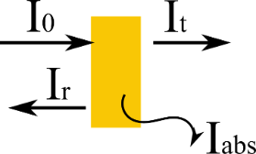
Fig. S6. Two-port symmetry model for optical transmission of plasmonic metasurfaces.
I₀, I_{t}, I_{r} and I_{abs} indicate the incident light, the transmittance, the reflectance and the absorbance, respectively.
The effective absorption is given by A_{eff} = α_{eff}L, where L is the penetrating distance of the incident light and α_{eff} is the effective absorption coefficient, which can be regarded as a combination of the linear absorption and nonlinear absorption evens, e. g. two- and three-photon absorption. Thus, the effective absorption coefficient is given by
$$\begin{aligned}α_{eff}=α_{0}+βI_{0}+γI_{0}^{2}+…\#\left(S2\right)\end{aligned}$$
where α₀, β and γ are the linear, two-photon and three-photon absorption coefficients, respectively. β is also commonly called nonlinear absorption coefficient for simplification, which is connected with the both imaginary part and real part of the third-order susceptibility ³.
Now we consider the saturation absorption in a relatively intense light, which can be modeled as:
$\begin{aligned}α_{eff}^{'}=\frac{α_{s}}{1+{I_{0}}/{I_{sat}}}+α_{ns}\#\left(S3\right)\end{aligned}$
where α_{s} and α_{ns} represent saturation loss and unsaturated loss, respectively ⁴. I_{sat} is the saturated intensity. Considering the saturation absorption is generally induced by both linear and nonlinear optical effects, then (S3) can be further written as:
$\begin{aligned}α_{eff}^{'}\left(I_{0}\right)=\frac{α_{0}+βI_{0}+γI_{0}^{2}+O\left(I_{0}^{3}\right)}{1+{I_{0}}/{I_{sat}}}+α_{ns}\#\left(S4\right)\end{aligned}$
Universal intensity-dependent optical absorptions (transmissions) could be basically described by a generalized Fermi-Dirac (sigmoid) function combining both the unsaturation and saturation absorption processes:
$\begin{aligned}T\left(x\right)=a+\frac{b}{1+c∙e^{-dx}}\#\left(S5\right)\end{aligned}$
The motivation mainly origins from the fact that a generalized Fermi-Dirac function is mathematically equivalent to expression (S4) but offers straightforward characteristic parameters for saturation absorption, including linear absorption coefficient, saturated intensity and modulation depth. Indeed, as shown in Fig. S7, the experimental transmission spectrum (opened stars) is fitted with the function (S5) (dashed cyan curve). The linear transmission level T_{l} and the modulation depth M_{d} can be extracted directly from the parameters of a and b, respectively. The saturation power P_{sat} corresponds to the transmission level T_{sat} = T_{l}+M_{d}/2 and unsaturated transmission is obtained by (1-T_{l}-M_{d}).
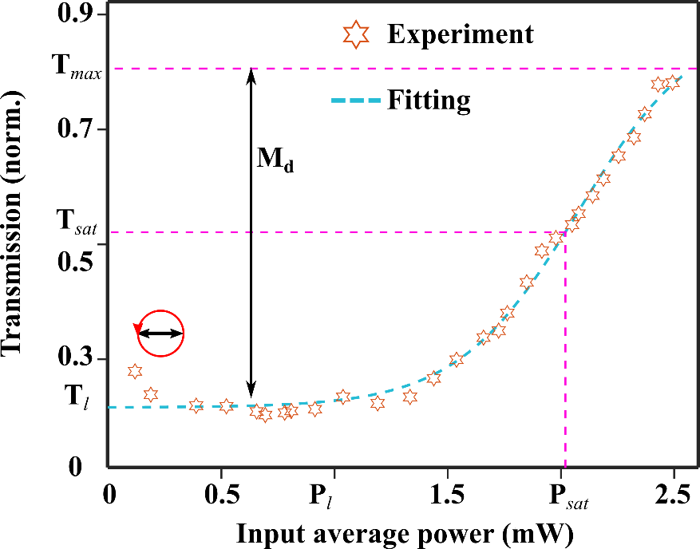
Fig. S7. Nonlinear transmission spectrum and the numerical fitting
Here below we explain the reason why a generalized Fermi-Dirac function is mathematically equivalent to the expression (S4).
First, (S4) can be expressed as:
$α_{eff}^{'}\left(x\right)=\frac{1}{1+x}\left(α_{0}^{'}+β^{'}x+γ^{'}x^{2}+O\left(x^{3}\right)\right)+α_{ns}$ for x=I₀/I_{sat},
and can be further generalized as:
$$\begin{aligned}α_{eff}^{'}\left(x\right)=α_{0}^{''}+{β^{'}}^{'}x+γ^{''}x^{2}+O\left(x^{3}\right)\#\left(S6\right)\end{aligned}$$
with the known Fourier expansion near zero 1/(1+x) = 1- x + x²- x³+ O(x⁴).
Similarly, given the Fourier expansion of a normalized Fermi-Dirac function σ(x) = 1/(1+e^{-x}) = 1/2+x/4 -x³/48 + O(x⁴), the generalized form T(x) = a+ b/(1+c*e^{-dx}) can thus be expanded as T(x) = α’₀ + β’x + γ’ x² + O(x³), with only a difference of a scaling factor for each term from (S6).
In most cases, the saturation absorption coefficient in (S3) is simplified as
$$\begin{aligned}α_{eff}^{'}=\frac{α_{0}}{1+{I_{0}}/{I_{sat}}}+α_{ns}\#\left(S7\right)\end{aligned}$$
since the linear absorption normally dominates the saturation loss (α_{s}≈α₀). We notice here that the generalized Fermi-Dirac function T(x) is still valid to describe such saturation absorption behaviors. The normalized Fermi-Dirac function σ(x) can be simplified by only remaining the first two terms of Fourier series of the denominator
$σ\left(x\right)=\frac{1}{1+e^{-x}}=\frac{1}{1+\sum_{k=0}^{∞}{\frac{{\left(-x\right)}^{k}}{k!}}}=\frac{1}{1+1-x+O\left(x^{2}\right)}≈\frac{1}{2-x}$ for $x∈\left[-1,1\right]$
Thus, T(x) can be expressed in a similar form as equation (S7) as
$$T\left({I_{0}}/{I_{sat}}\right)=\frac{α_{0}^{'}}{1+{I_{0}}/{I_{sat}}}+α_{ns}^{'}$$

7. Soliton mode-locking at 2 μm
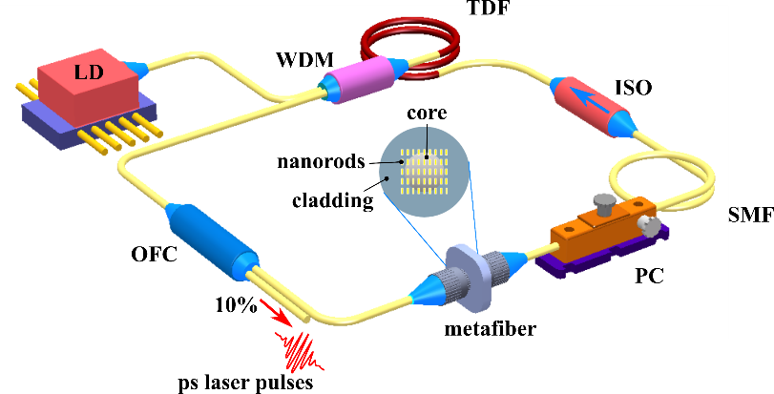
Fig. S8. Scheme of a home-built ultrafast thulium-doped fibre laser integrating a metafiber SA, where LD represents the laser diode, WDM is the wavelength-division multiplexer, TDF is the thulium-doped fibre, ISO is the optical isolator, OFC is the output fibre coupler, SMF is the single-mode fibre, PC is the polarization controller.
A fibre cavity shown in Fig. S8 is built, which includes a 1550 nm pumping laser diode (LD), a 1560/2000 nm wavelength multiplexer (WDM), 10 cm thulium doped fibre (TDF, SM-TSF-5/125), a polarization-insensitive isolator (ISO), a polarization controller (PC), and an output fibre coupler (OFC). The coupler extracts 10% of the laser energy for the pulse characterizations. The overall length of the cavity is 14.9 m with anomalous net chromatic dispersion, and all of the fibre connections are made with standard single-mode fibres (SMFs, 11.5m long). An InGaAs PIN detector (Newport, 818-BB-51F) is employed to monitor the output signal.
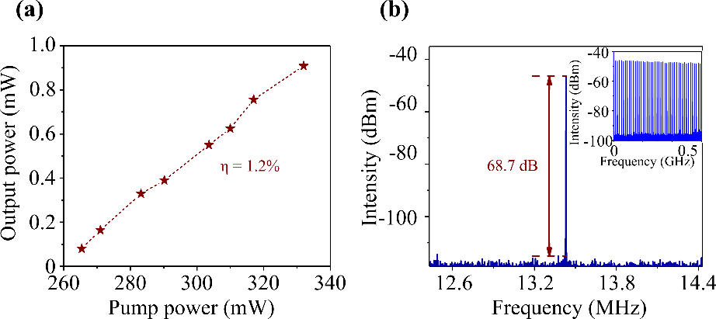
Fig. S9. Soliton mode-locking at 2 μm of a home-built fibre laser integrating a plasmonic metafiber. (a) Averaged output power of a home-buit 2 μm fibre laser as functions of the pump power. (b) RF spectra of the soliton pulses with a scanning range of 2 MHz and a resolution of 300 Hz. Inset shows the RF spectra of the soliton pulses with a scanning range of 0-0.6 GHz and a resolution of 10 KHz.
When the metafiber is implemented in the fibre laser cavity, stable mode locking is achieved by increasing the pump power and tuning the polarization controller. Fig. S9(a) shows the laser conversion efficiency is ~1.2% for the metafiber. The pump power of a stable mode-locked pulse trains starts from 265 mW. Fig. S9(b) shows the RF spectra of the soliton mode-locked pulse at the pump power of 310 mW. The signal-to-noise ratio of the fundamental frequency of the laser reaches 68.7 dB at a resolution of 300 Hz, and it is greater than 45 dB in the range of 0-0.6 GHz at a resolution of 300 kHz, indicating a high stability of the mode locking.
8. Thermal damage threshold estimation
When the mode-locked pulses (pulse duration 513 fs, repetition rate 22.7 MHz) were generated, the maximum averaged power in our fibre laser cavity was 1.16 mW (when the pump power reaches to 88 mW). The maximum laser fluence inside the laser cavity can be calculated as 0.08 mJ cm⁻². From the literature ⁵⁻⁷, the damage threshold of gold nanorods is within a 2.5-5.6 mJ cm⁻² range, which is far beyond the maximum value of laser fluence in our laser cavity. Therefore, no visible thermal damages were observed from SEM images after all the mode-locking experiments.
9. Optical nonlinearity induced plasmonic resonance shift
Power dependent transmission spectra for the plasmonic metasurface are calculated by using finite element method (COMSOL Multiphysics). The model system is shown in Fig. S10(a), taking the periodic conditions into account.
In such a unit cell, an Au nanorod with the length L = 470 nm, width W = 160 nm and the thickness T = 60 nm locates on a substrate of refractive index n = 1.5, excited by a linearly polarized plane wave coming from the air side of the interface. The longitudinal and transverse periods keep the same: P_{x} = P_{y} = 750 nm. Port 1, 2 are input and output light ports, respectively. The peak power Pin for the input port is calculated from experimental laser parameters in accordance with the following formula:
$$\begin{aligned}P_{in}=\frac{P_{k}}{N}=\frac{{P_{avg}}/{\left(f∙τ\right)}}{{\left(d/{P_{x}}\right)}^{2}}\#\left(S8\right)\end{aligned}$$

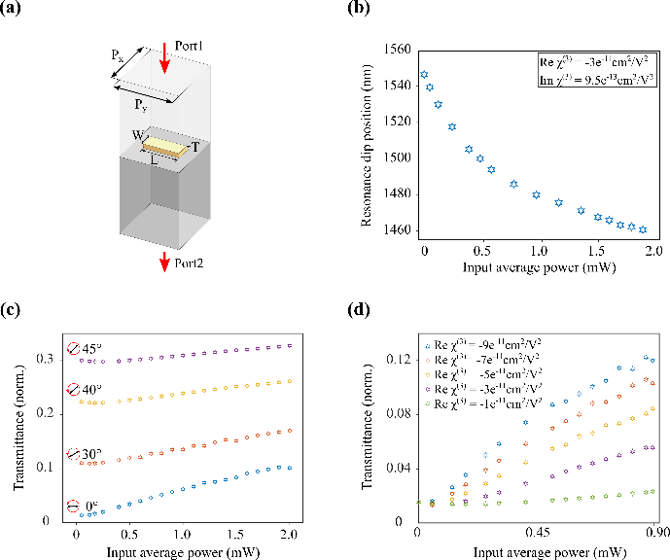
Fig. S10. Theoretical calculations on the power-dependent transmission spectra of a nanorod metasurface. (a) 3D optical model system for the calculation of power-dependent transmission. P_{x} and P_{y} are the transverse and longitudinal periods of an Au nanorod array, respectively. L, W and T denote respectively the length, the width, and the thickness of the nanorods. (b) Optical nonlinearity induced dip position shifts of transmission spectra of the nanorod array. (c) Power- and polarization-dependent transmission of the nanorod array in on-resonance (optical wavelength1550 nm) excitation condition. The black arrows represent the polarization angles with respect to the long axis of nanorods. (d) Power-dependent transmission of the nanorod array in the low input power regime as functions of Reχ³.
where P_{k} is the laser peak power, N is the number of unit cell in the beam focus, P_{avg} is the averaged power in the focus, f is the repetition rate, τ is the pulse duration, d is the beam diameter. The laser parameters in our experiment are listed in Table S1.
Table S1. Laser parameters used in the experiment
Laser parameter | value
λ | 1550 nm
P_{avg} | 0-2.5 mW
f | 10.32 KHz
τ | 179 fs
d | ~85 μm
In order to quantify the plasmonic resonance shift promoted by the high laser power, the optical nonlinearity dominated by the Kerr effect is considered. The relative permittivity of Au nanorods is expressed as:
$$\begin{aligned}ε= ε_{L}+\frac{3}{2}\left(Reχ^{3}-iImχ^{3}\right)E_{int}^{2}\#\left(S9\right)\end{aligned}$$
where ε_{L} is the linear relative permittivity, E²_{int} is the square of internal electric filed, χ³ is the third-order susceptibilities, Reχ³ and Imχ³ are the real part and imaginary part of χ³. Dispersed ε_{L} is obtained from literature ¹. We notice that the χ³ values from Au films should not be used, as there are significant differences between the bulk materials and the nanostructures. Referred from the literature ³, the absolute value of Reχ³ of plasmonic nanostructures is in the orders of 10⁻¹⁰-10⁻¹² cm² V⁻² and the absolute value of Imχ³ is in the orders of 10⁻¹⁰-10⁻¹³ cm² V⁻², which strongly depend on the excitation wavelength and the polarization. For instance, the absolute values of Reχ³ and Imχ³ are almost two orders smaller for the off-resonance situation compared with the plasmon-resonant excitation wavelength ³. In the following calculations, initial values of Reχ³ and Imχ³ are respectively set similarly to those ³: -3×10⁻¹¹ cm² V⁻² and 9.5×10⁻¹³ cm² V⁻² and later we will test how significant the χ³ values influent our results. The transmission spectra in each input power are obtained by sweeping the optical wavelength from 1300 nm to 1700 nm, as it is shown in Fig. 6(d) in the main text. The transmission dip positions are extracted from the spectra and plotted in Fig. S10(b) as a function of averaged input power. The dip position shows an obvious blue shift as the input power increases, e. g. the dip position is shifted to 1457 nm from initial 1550 nm when the input power increases from 0.25 μW to 2 mW.
Focusing on the optical wavelength of 1550 nm, we calculate the power- and polarization-dependent transmission for the nanorod array as well. As shown in Fig. S10(c), for each polarization angle θ, the transmission level shows a ‘S’-shape profile, which agrees with the experimental results shown in Fig. 6(b) in the main text. When θ changes from 0° to 45° with respect to the long axis of the nanorods, the transmission level in the low power regime (1-LA stage) increases due to a reduce of linear absorption of nanorod array. The modulation depth decreases as the θ increases from 0° to 45°, which generally agrees with the results shown in Fig. 2(d) in the main text.
However, we also observe that the maximum modulation depth in this model is less than 10%, which is much smaller than the experimental results shown in Fig. 2(d) and Fig. 6(b) in the main text. One of potential reasons could be that the χ³ values of plasmonic metasurfaces are power dependent, rather than constants. Fig. S10(d) shows an example how the χ³ values influence the transmission level of the nanorod array in the lower input power regime (0-0.9 mW). As the absolute value of Reχ³ increases, the transmission at the same input power increases. Following the similar tendency, the transmission in the nonlinear absorption (2-NA) and saturated absorption (3-SA) stages should reach higher levels as well, resulting in a larger modulation depth in the end. Thus, to better interpret the experimental results, the absolute values of Reχ³ should first increase with the input laser power and finally approach a constant. Considering the tight connections between the absorption coefficients and χ³ of plasmonic nanoparticles ⁸, the Reχ³ should follow a similar ‘S’-shaped profile defined in (S4) or (S5). These assumptions need further in-depth theoretical and experimental demonstrations, taking the contributions from the intraband transitions, interband transitions and the hot electrons into account ⁸, which is, however, far beyond the scope of this work.
References

1. H. R. Philip, Handbook of Optical Constants of Solids. Acedemic press, New York, 1998.
2. Fan, S., Suh, W. & Joannopoulos, J.D. Temporal coupled-mode theory for the Fano resonance in optical resonators. J. Opt. Soc. Am. A. Opt. Image Sci. Vis. 20, 569-572 (2003).
3. Menezes, L.d.S. et al. Large third-order nonlinear susceptibility from a gold metasurface far off the plasmonic resonance. J. Opt. Soc. Am. B 36 1485-1491 (2019).
4. Zhao, D. et al. Plasmonic Saturable Absorbers. Adv. Photonics Res. 2, 2100003 (2021).
5. Huang, W., Qian, W. & El-Sayed, M.A. Gold nanoparticles propulsion from surface fueled by absorption of femtosecond laser pulse at their surface plasmon resonance. J. Am. Chem. Soc. 128, 13330-13331 (2006).
6. Nanophotonics: plasmonics and metal nanoparticles. Phys. Chem. Chem. Phys. 11, 5866 (2009).
7. Taylor, A.B., Siddiquee, A.M. & Chon, J.W. Below melting point photothermal reshaping of single gold nanorods driven by surface diffusion. ACS Nano 8, 12071-12079 (2014).
8. Hache, F. et al. The optical kerr effect in small metal particles and metal colloids: The case of gold. Appl. Phys. A 47, 347-357 (1988).

